Golborne Hockey Club - Junior Training Sessions
at Golborne Sports Club
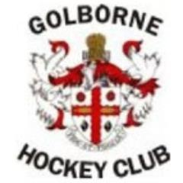
Sundays - 10am-11am
If you have tried hockey at school or fancy having a go, then why not come down to Golborne Sports & Social Club and participate in our Junior training sessions. (Ages 4-13)
Our dedicated coaching team comprising of L2 and L1 coaches along with aspiring young leaders who play for the club will ensure you have lots of fun and learn new skills.
First session free!
then £1 a session or £15 for the year

Contact: Gareth Edwards-Jones
07801999298
Gazjones79@yahoo.co.uk

